ORGANISATION SERVICE TREE TEMPLATE
What is a service tree?
A Service Tree refers to the list of services within an organisation or service provider, and are normally in a hierarchical order. It is similar to the term ‘family tree’ where it starts from a single ancestor or the ‘parent’ organisation. That organisation will have all kinds of ‘child’ services that will be part of the service above it, and may have more services below it, for example a hospital (the ‘child’) will have departments that become a ‘descendant’ to the ‘parent’ organisation.
Why does Care Opinion need this information?
As part of the Tell Your Story process, authors are presented with an option to select the relevant service/s in which their experience happened. We refer to this as ‘linking’ a service to a story. This also enables subscribers to capture qualitative and quantitative data by using the platform’s searching and reporting features, based on services with stories linked.
How is it displayed on the website?
The following visualisations belongs to Kerang District Health which is the ‘parent’ with ‘child’ services including Kerang Hospital. But as wards, clinics and departments are added under Kerang Hospital, the hospital then becomes a ‘parent’ with ‘child’ services.
Figures 1 and 2 have been provided to give an understanding of how a service is broken down according to their hierarchical level and are not visible to subscribing services.

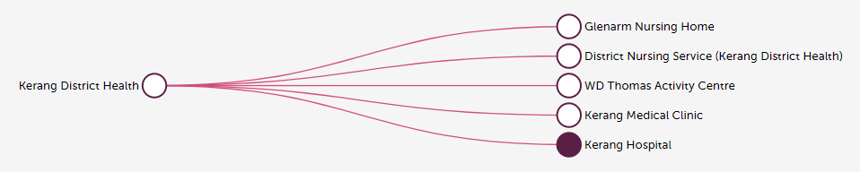
Figure 1 (COA internal visualisation)

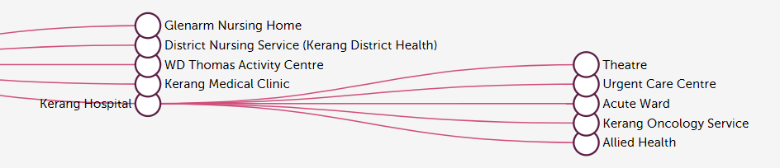
Figure 2 (COA internal visualisation cont.
Click here to see an example of what subscribers and the general public can see on a health service organisation's 'service page' on the Care Opinion platform. (Expand ‘More services within Kerang District Health’ to view the ‘child’ services under this ‘parent’, reflected in Figure 1).
What information do we need to provide?
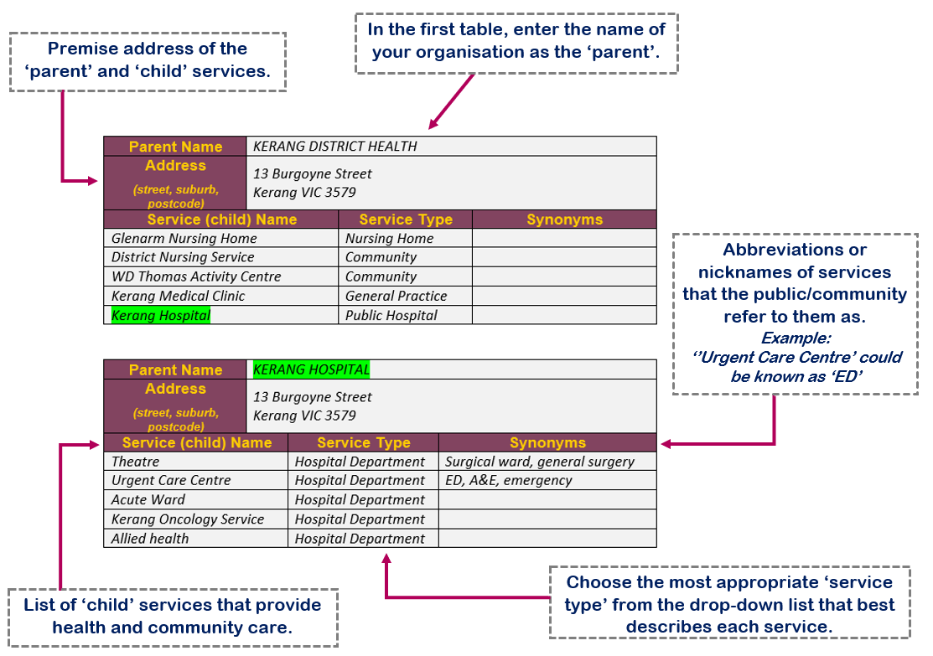
The capture below is a sample of Kerang District Health’s service tree template, describing each of the required fields. It is important that when naming each service, try to consider what the public understands, and find a balance between this and the official name of the service internally. Sometimes, the public will not know the official name, or an abbreviation of a specific medical term. This is especially true for hospital departments or care programs. It is helpful to include the ward letter and/or number if applicable – enter this information in the ‘synonyms’ column.
The child in the first table becomes the ‘parent’ in the second.
–––––––––––– COMPLETE TEMPLATES ON THE NEXT PAGE/S –––––––––––––

–––––––––––––––––––– FOR YOUR COMPLETION ––––––––––––––––––––
Following the guide above, please complete the tables below with a list of health and care services provided by your organisation/health service, to be uploaded on to the Care Opinion platform.
Should you have any queries regarding this template, please do not hesitate to contact the Care Opinion Australia Team on 07 3354 4525 or email info@careopinion.org.au
Parent Name
Address
(street, suburb, postcode)
Service (child) Name |  | Service Type | Synonyms
 |  | Choose an item.
 |  | Choose an item.
 |  | Choose an item.
 |  | Choose an item.
 |  | Choose an item.
Add more rows if required and enter the appropriate ‘service type’ from the drop-down list using free text.

Parent Name
Address
(street, suburb, postcode)
Service (child) Name |  | Service Type | Synonyms
 |  | Choose an item.
 |  | Choose an item.
 |  | Choose an item.
 |  | Choose an item.
 |  | Choose an item.
Add more rows if required and enter the appropriate ‘service type’ from the drop-down list using free text.

Parent Name
Address
(street, suburb, postcode)
Service (child) Name |  | Service Type | Synonyms
 |  | Choose an item.
 |  | Choose an item.
 |  | Choose an item.
 |  | Choose an item.
 |  | Choose an item.
Add more rows if required and enter the appropriate ‘service type’ from the drop-down list using free text.

Parent Name
Address
(street, suburb, postcode)
Service (child) Name |  | Service Type | Synonyms
 |  | Choose an item.
 |  | Choose an item.
 |  | Choose an item.
 |  | Choose an item.
 |  | Choose an item.
Add more rows if required and enter the appropriate ‘service type’ from the drop-down list using free text.

Parent Name
Address
(street, suburb, postcode)
Service (child) Name |  | Service Type | Synonyms
 |  | Choose an item.
 |  | Choose an item.
 |  | Choose an item.
 |  | Choose an item.
 |  | Choose an item.
Add more rows if required and enter the appropriate ‘service type’ from the drop-down list using free text.Duplicate table if required and use free-text where applicable.

